**Site-wide:**

* **\*IMPORTANT* - All custom work will need to be done through the child theme functions.php rather than the main them functions.php**
* **Fonts - These will need to be set site-wide**
  + Headlines - Bitter - weight: 600 - size: 50pt - Sentence Case
  + Sub-Headlines - Raleway - weight: 300 - size: 22pt - All Caps
  + Body Text - Raleway - weight: 500 - size: 14pt - Sentence Case
  + Links - Need to be set to the green color
  + Bitter Font - <https://fonts.google.com/specimen/Bitter>
  + Raleway Font - <https://fonts.google.com/specimen/Raleway>
* **Colors -** 
  + Green - #8D9939
  + Black - #231F20
  + Light Gray - #7A7A7A
  + Dark Gray - #585955
* Black bar at the bottom of the footer - Set copyright date to update automatically each year.
* 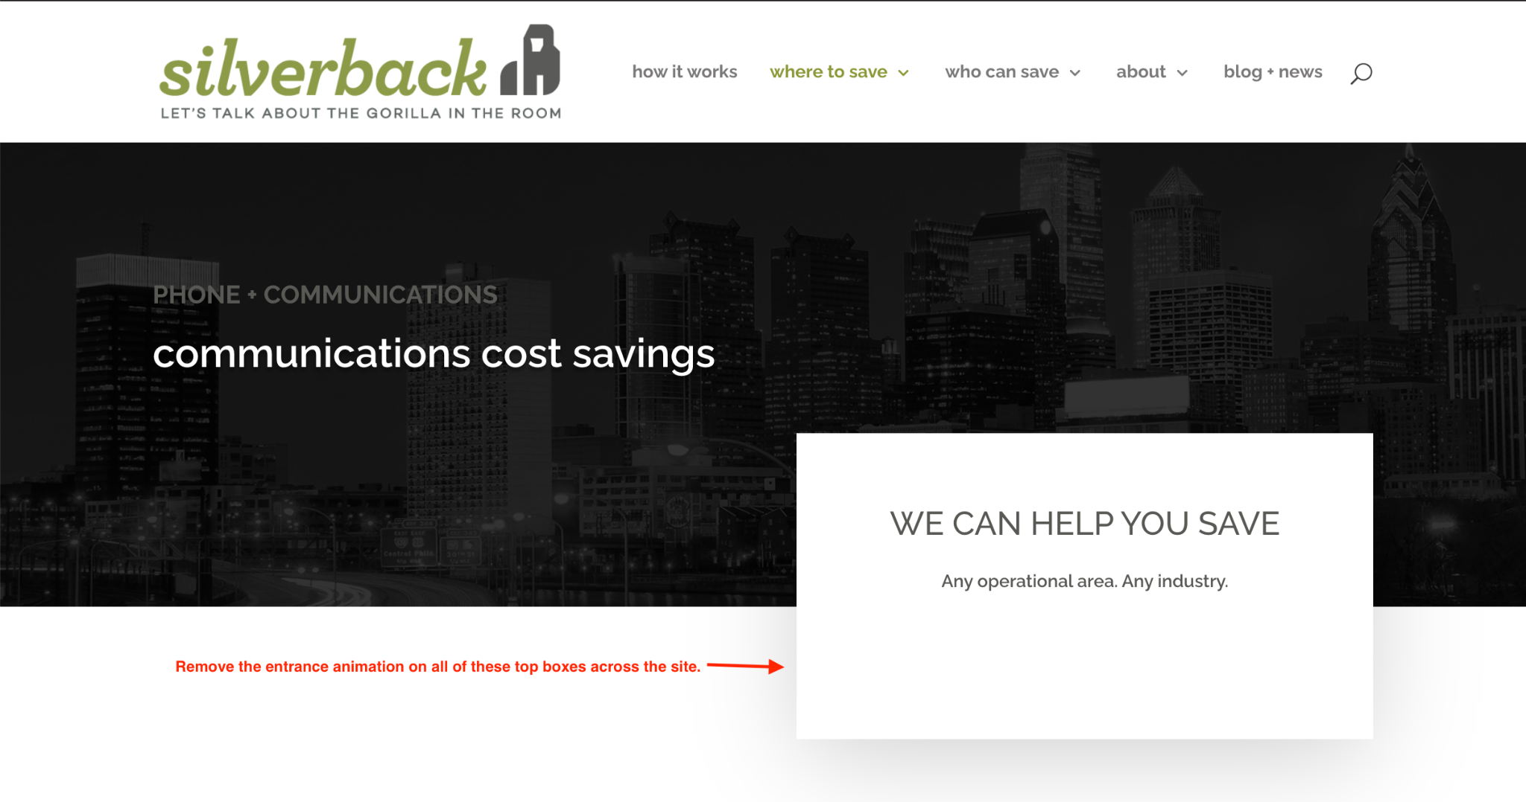
  + In these same white boxes, there is a ‘Contact Us’ button below the two lines of text. The button is currently White. Please change the background color of the buttons to green.
  + On Mobile - These boxes are overlapping the top headlines and have too much padding below them.  
     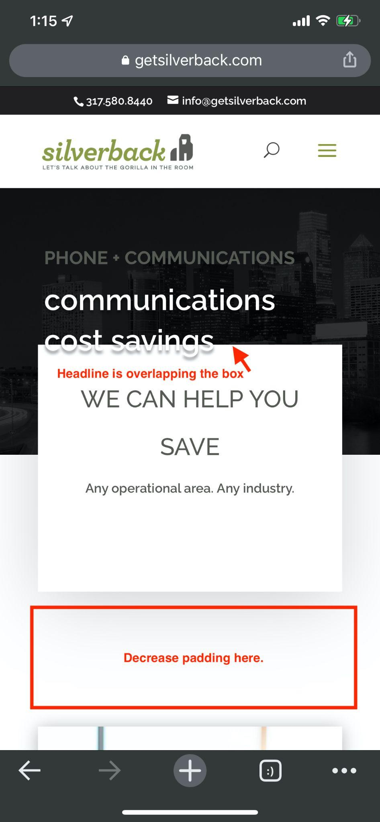

**Home Page Desktop:**

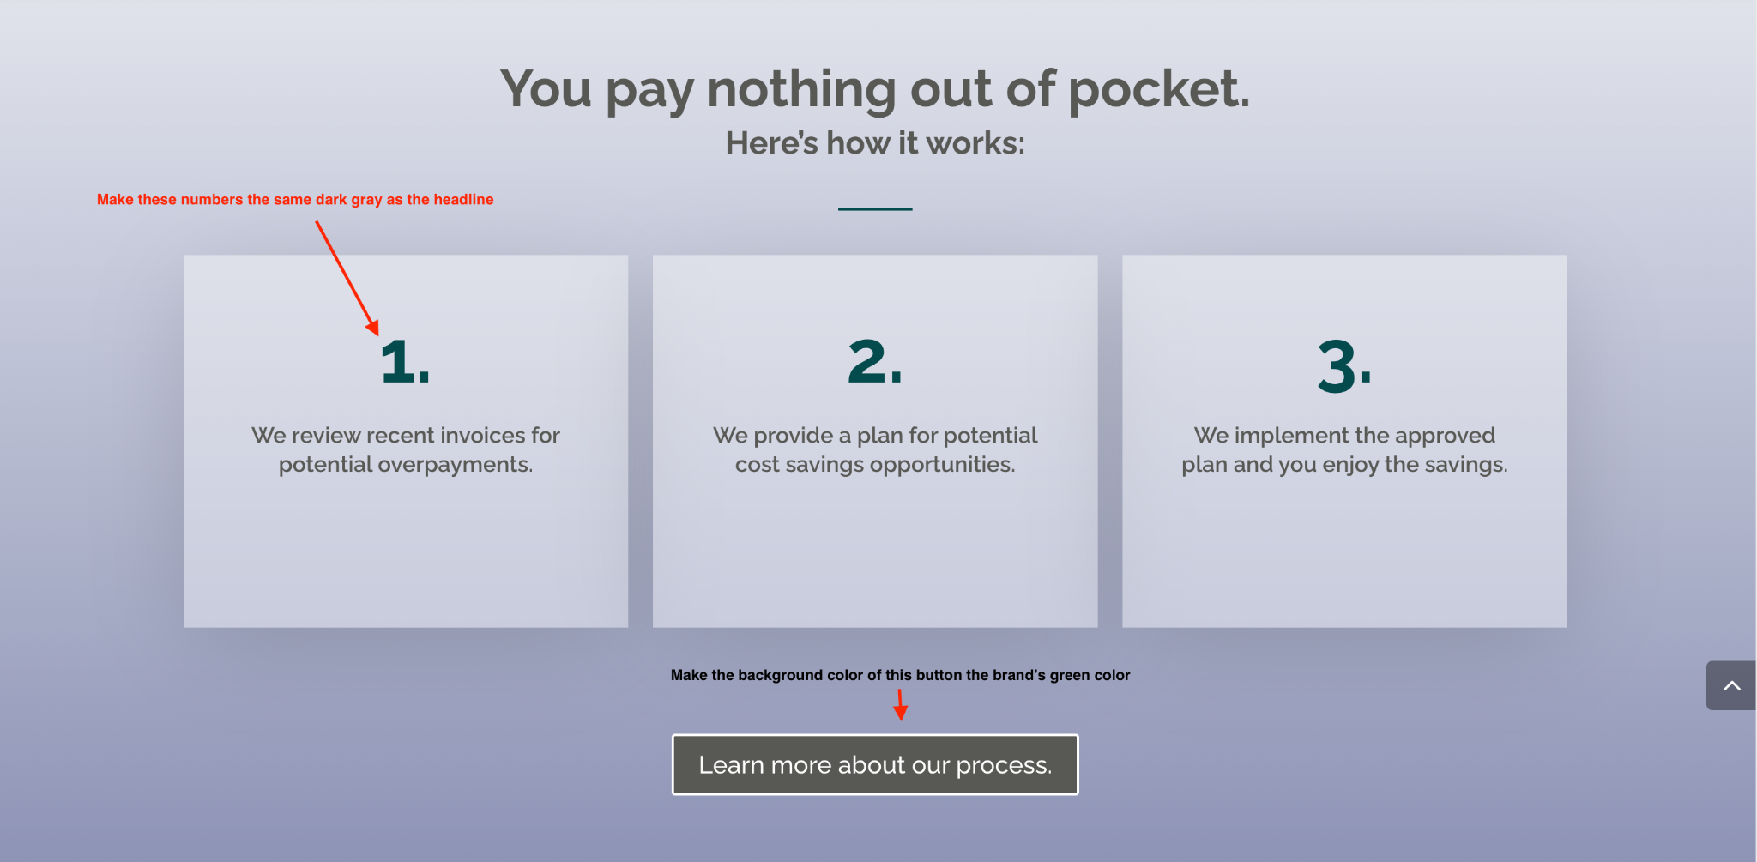

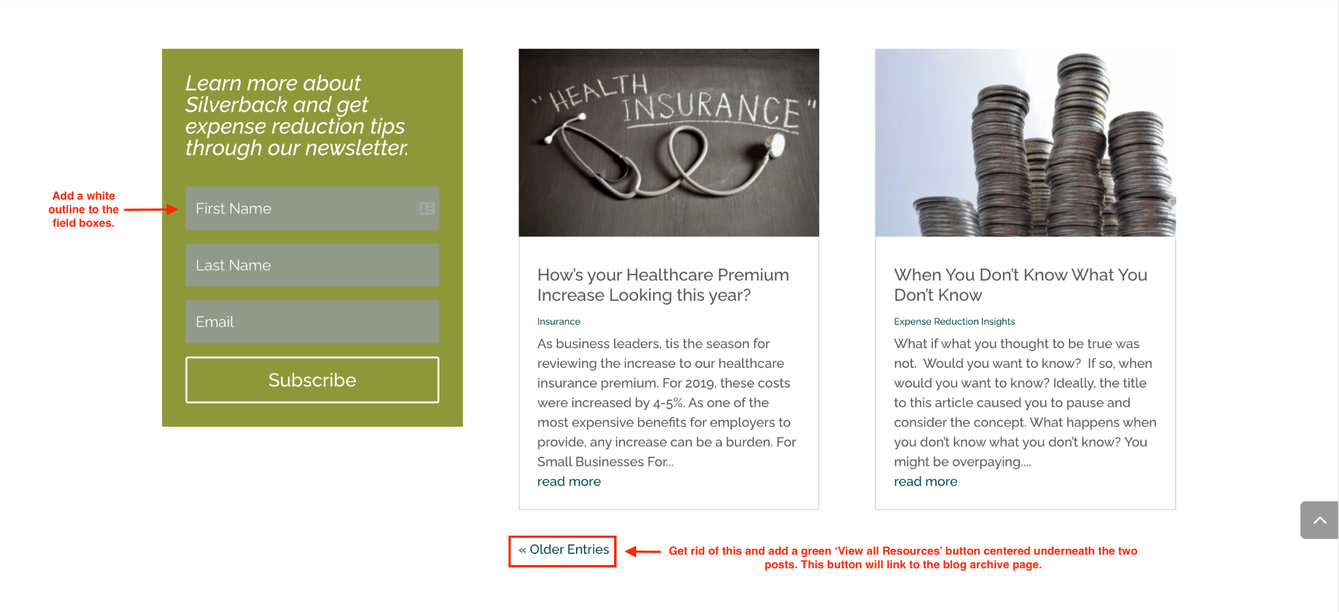

**Home Page Mobile:**

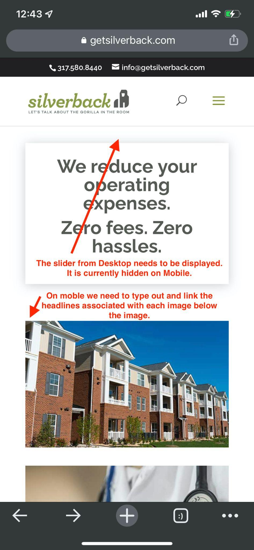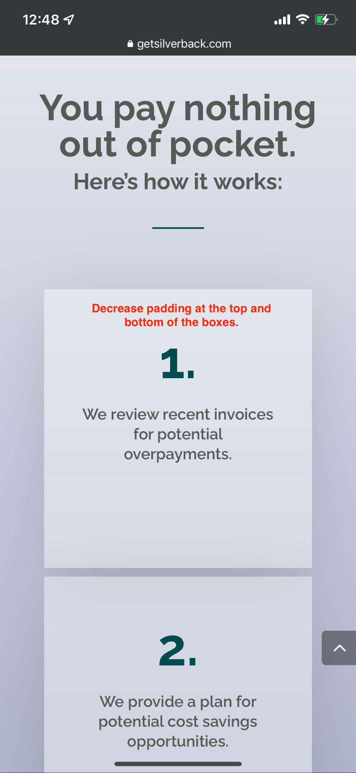

**How It Works Page - Desktop:**

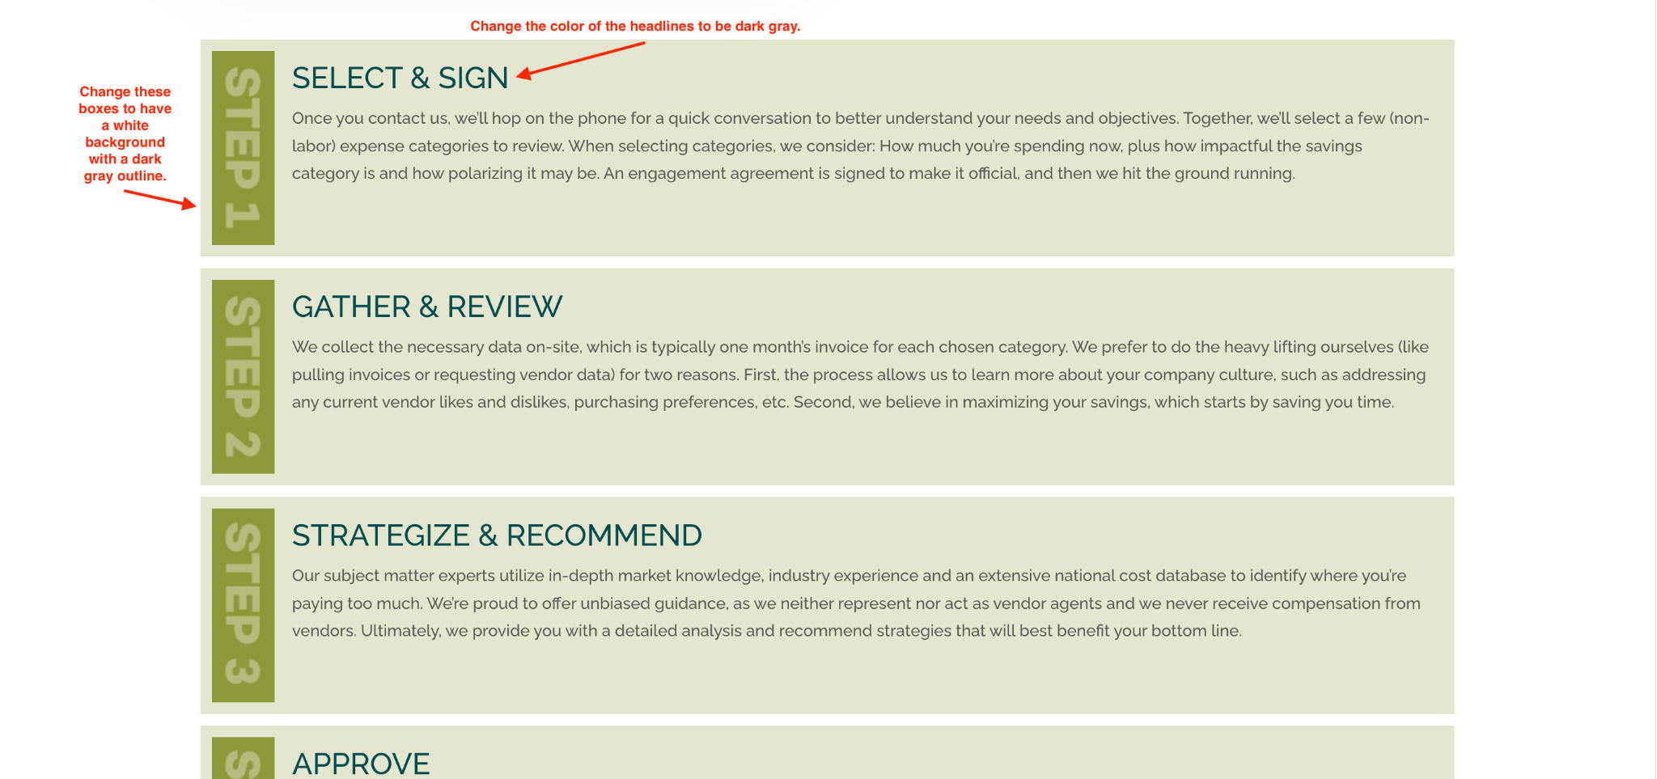

**How It Works Page - Mobile:**

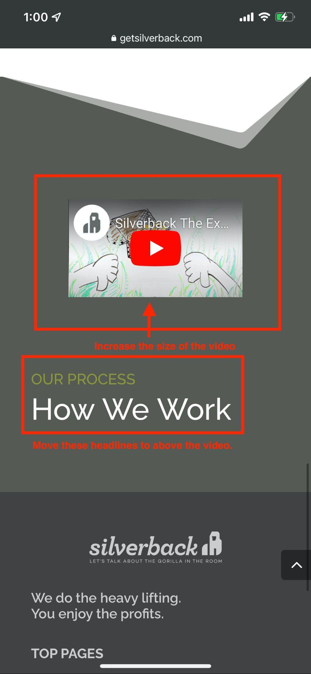

**Telecom + Communications Page - Desktop:**

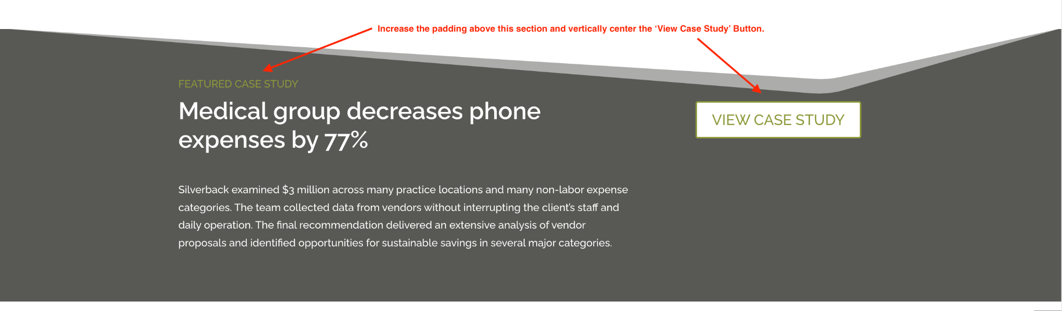

^^ This feedback will apply to this section on all pages under the ‘Where to Save’ and ‘Who Can Save’ navigation heading. ^^

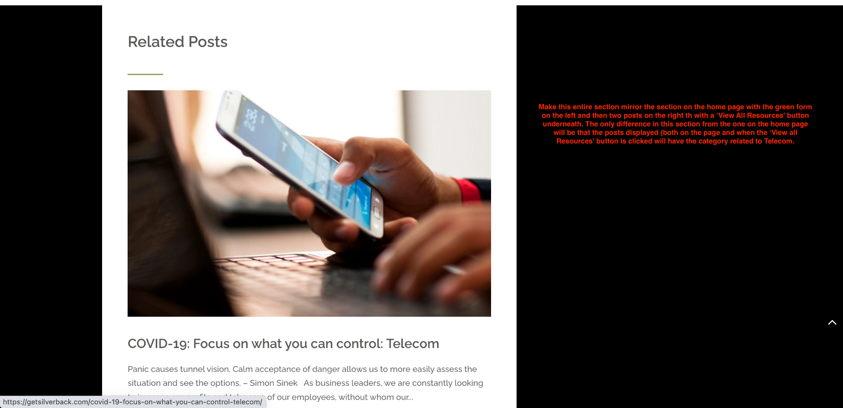

^^ This feedback will apply to this section on all pages under the ‘Where to Save’ and ‘Who Can Save’ navigation heading. ^^

**About Page - Desktop:**

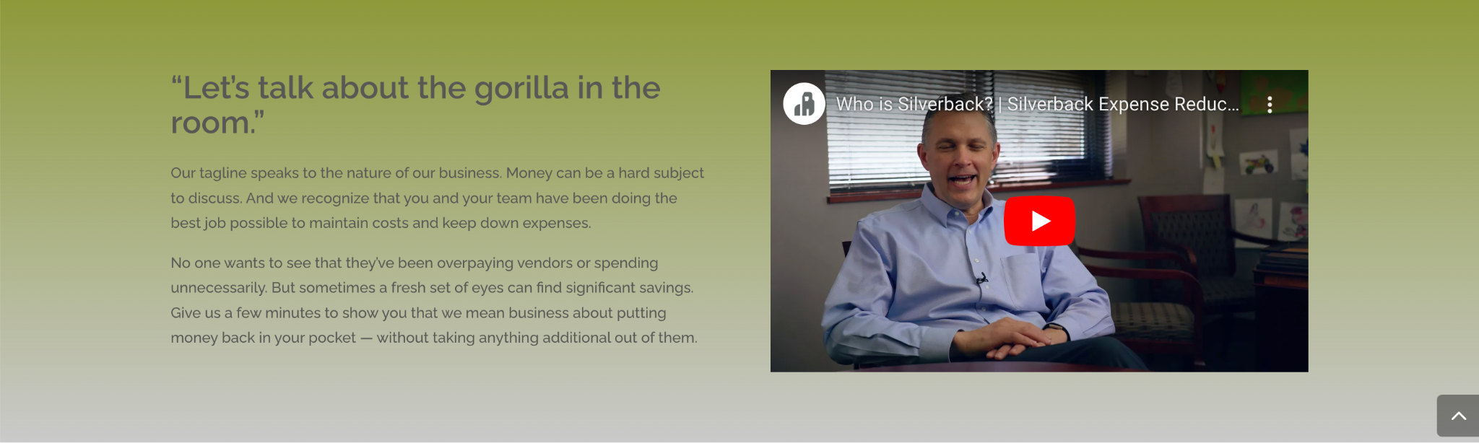

Change the background of this section to be a gradient from Dark gray to Light gray instead of Green to Light gray. Also change the headline and body text color to white.

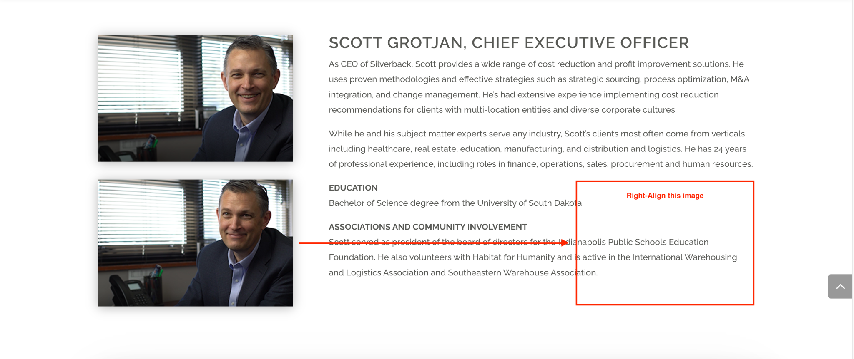

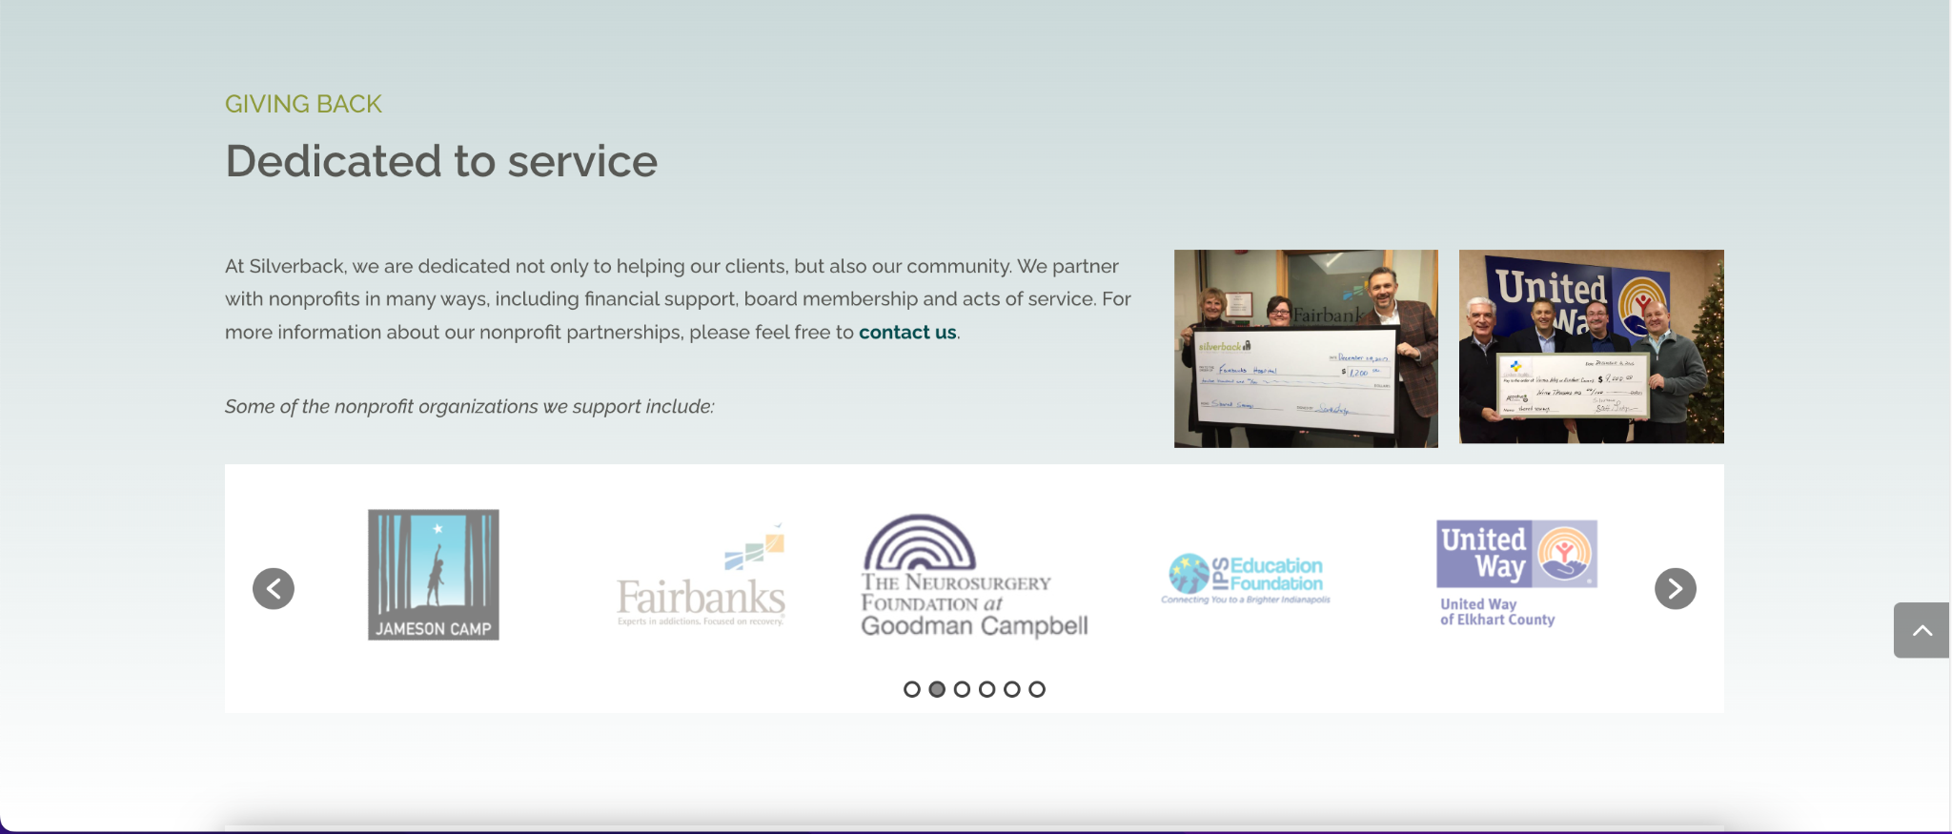

Change the background of this section to be white.

**About Page - Mobile:**

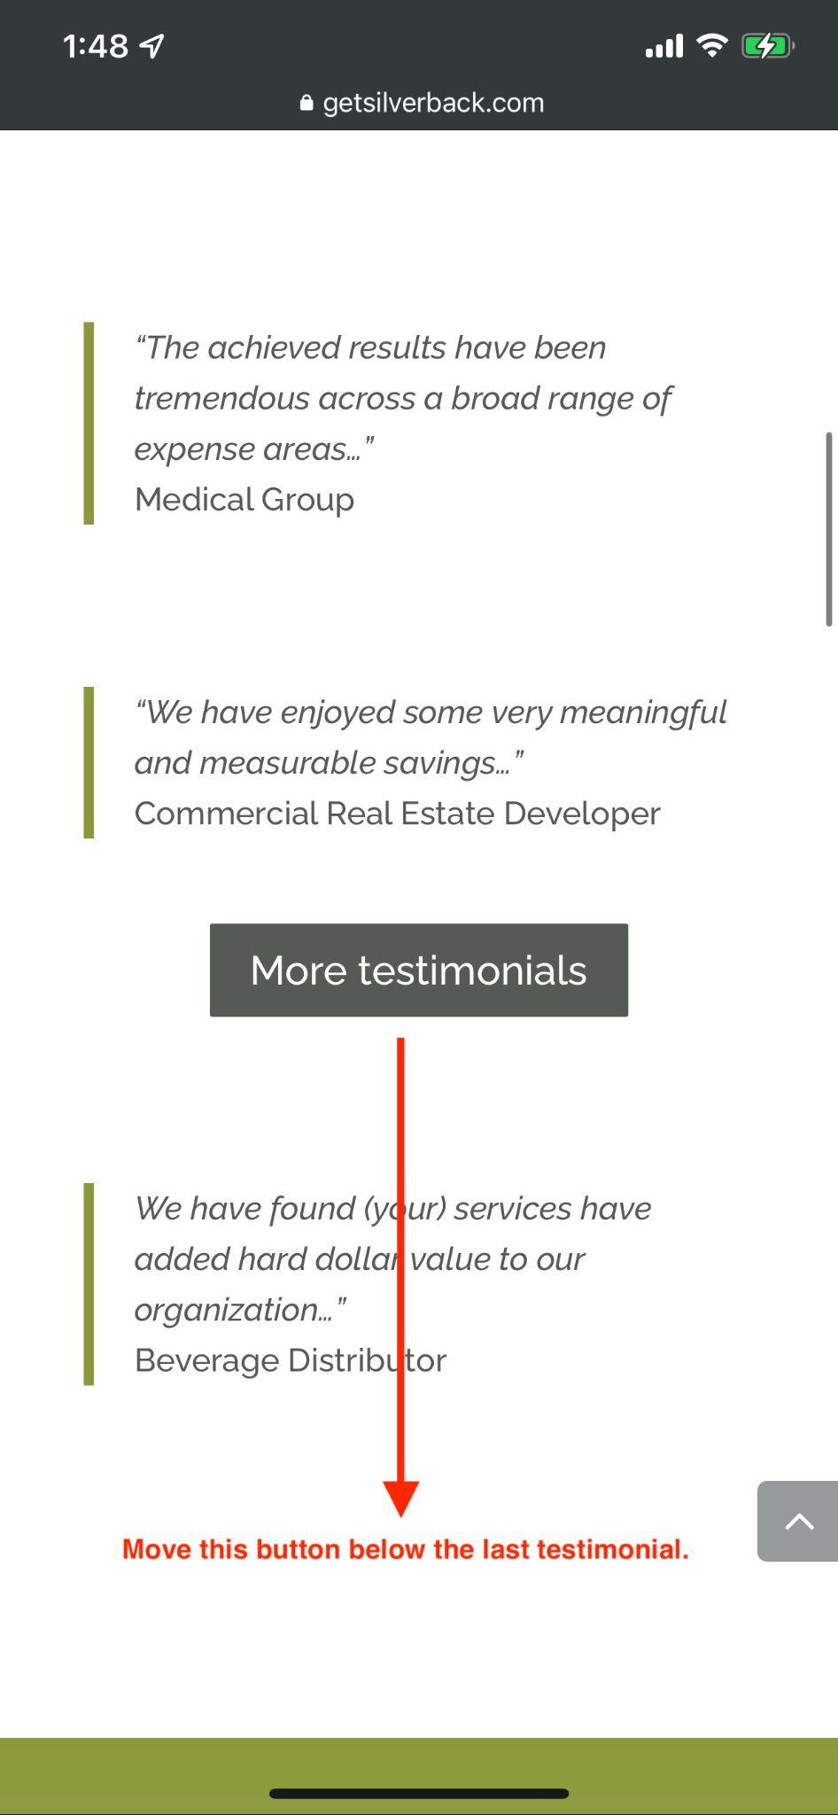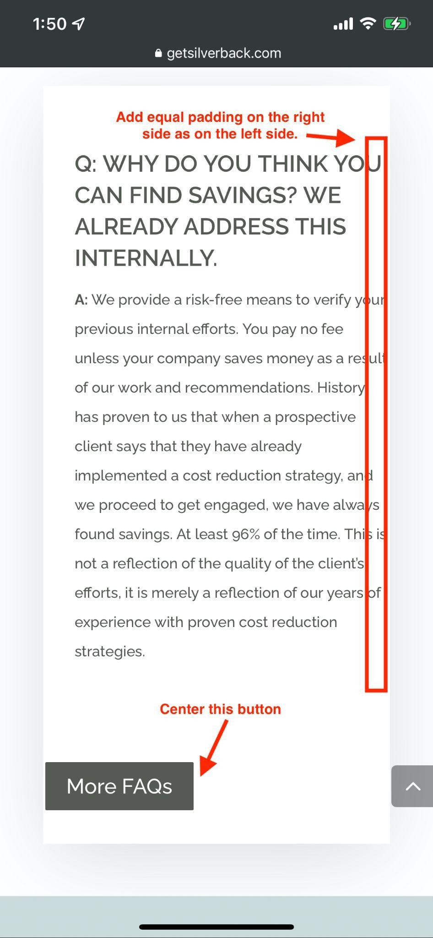

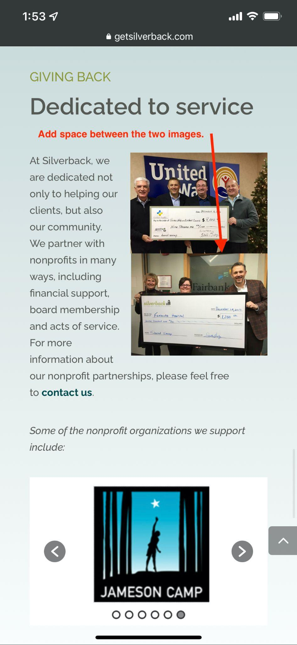

**Cast Studies Page - Desktop:**

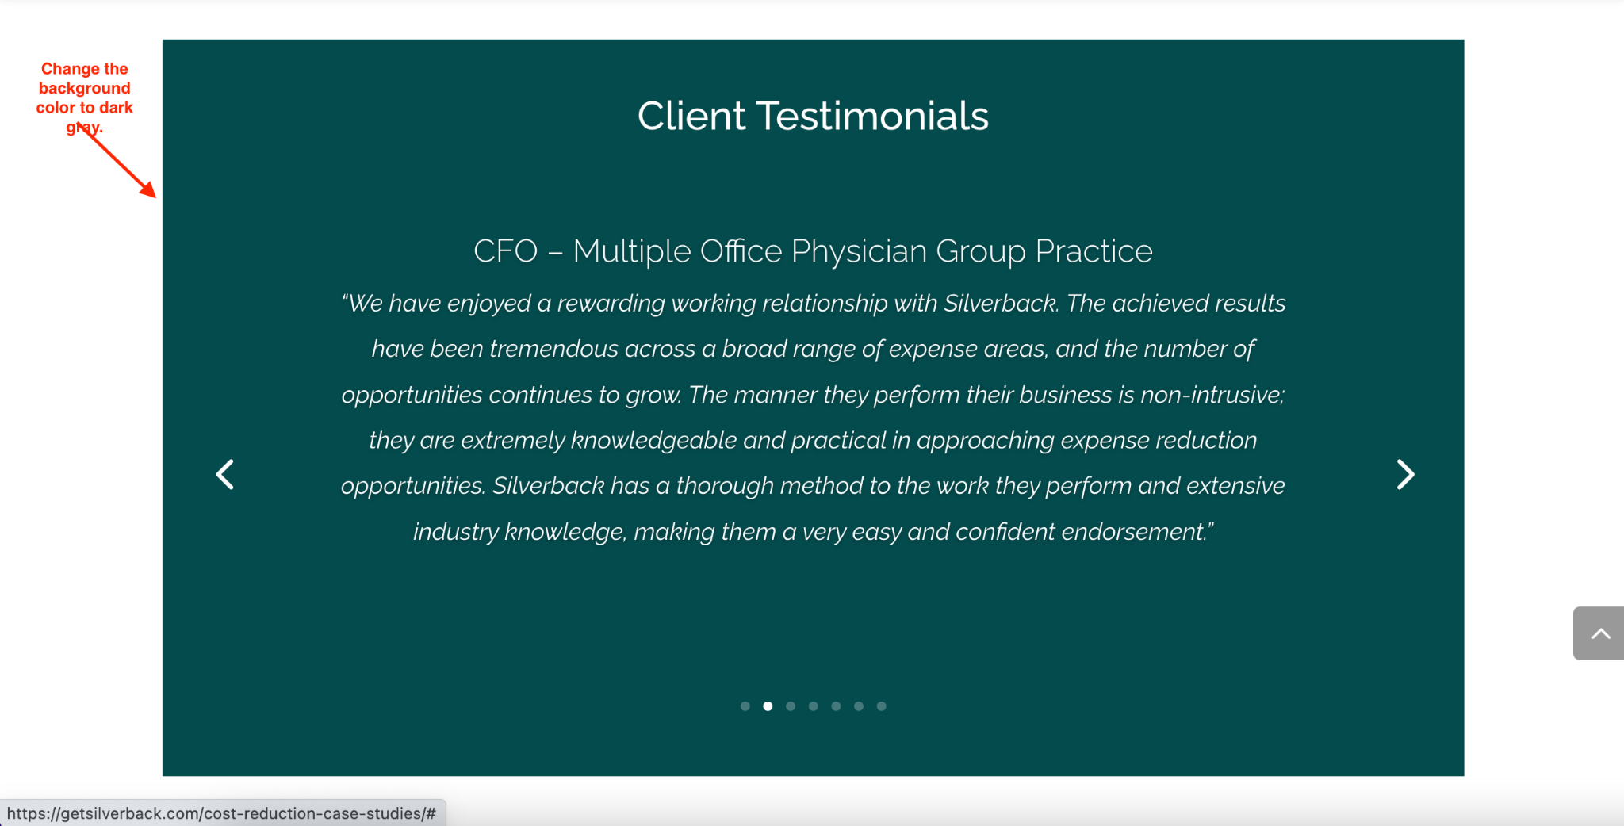

**Case Studies Page - Mobile:**

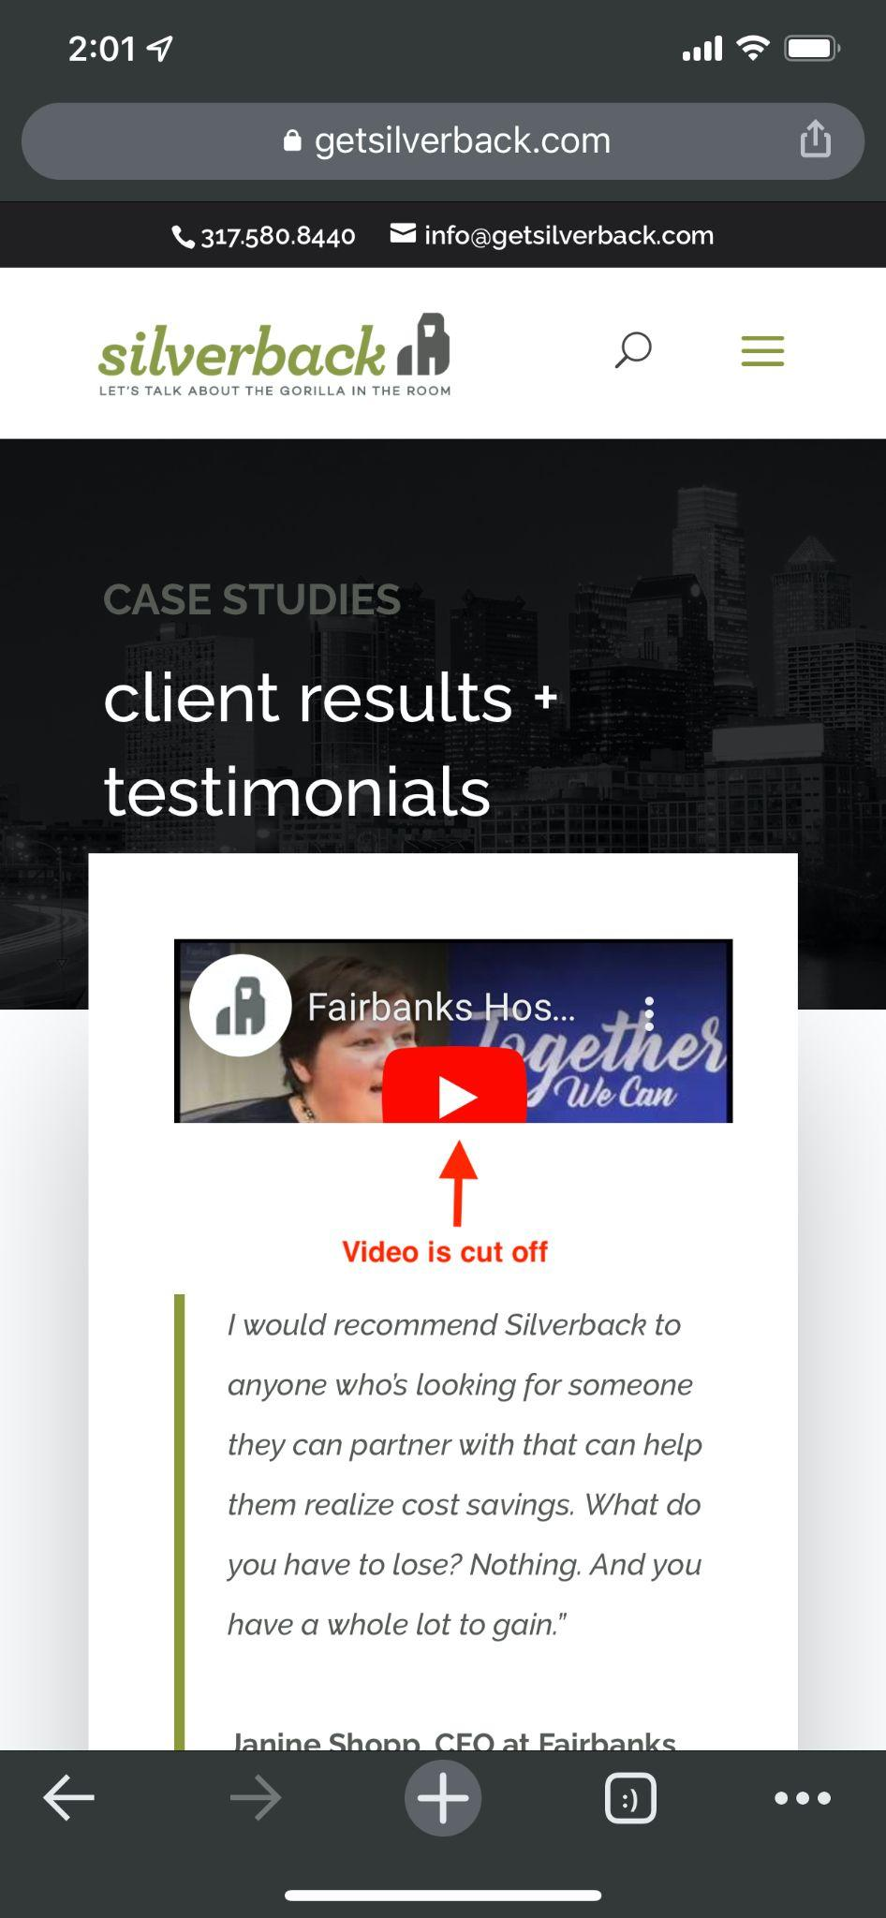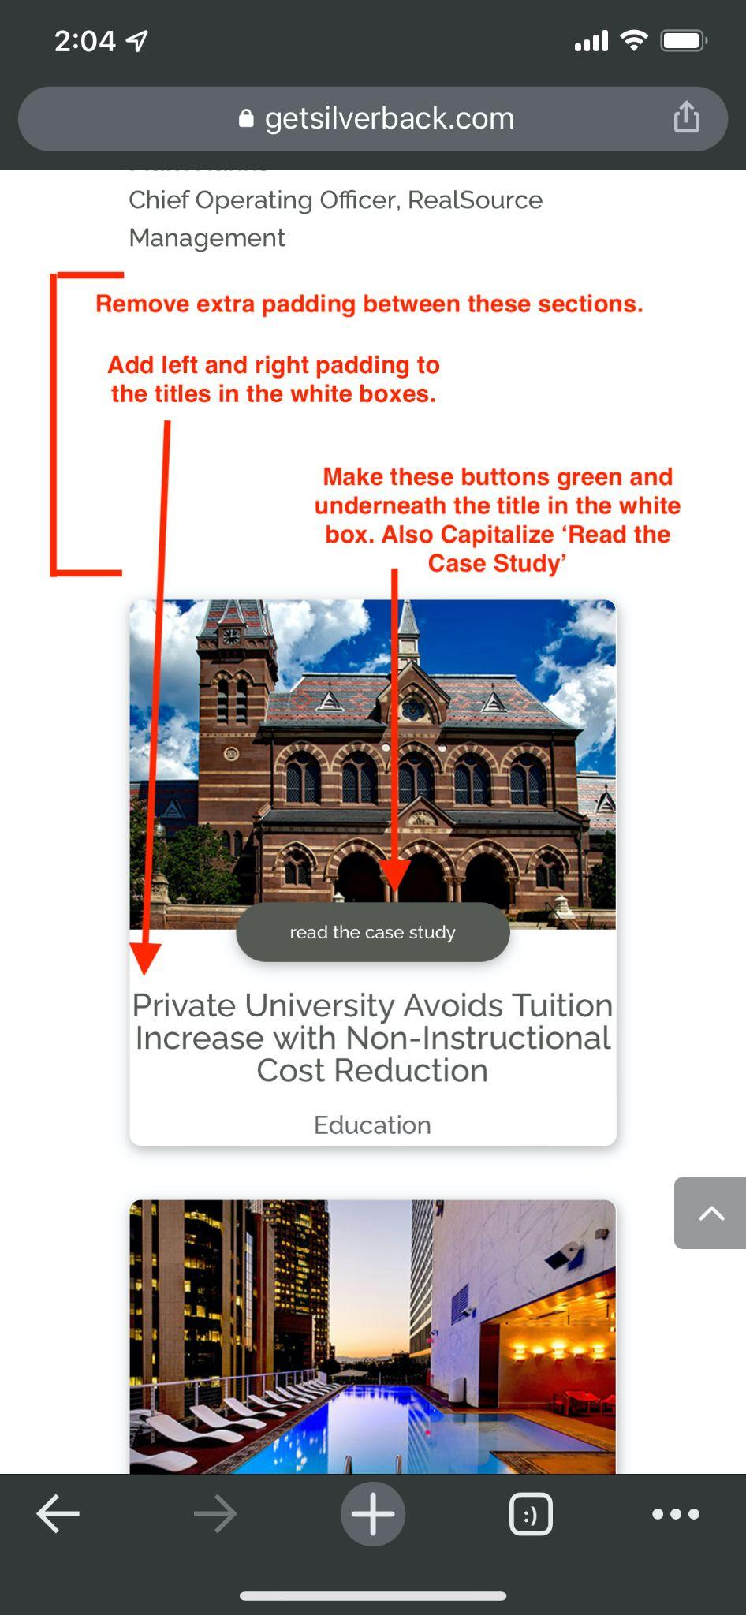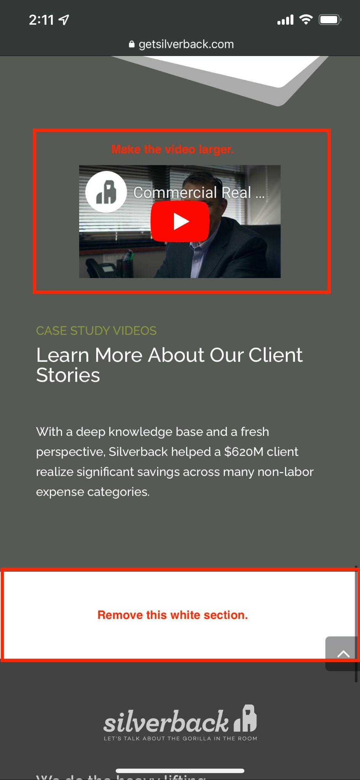

**FAQ Page Mobile:**

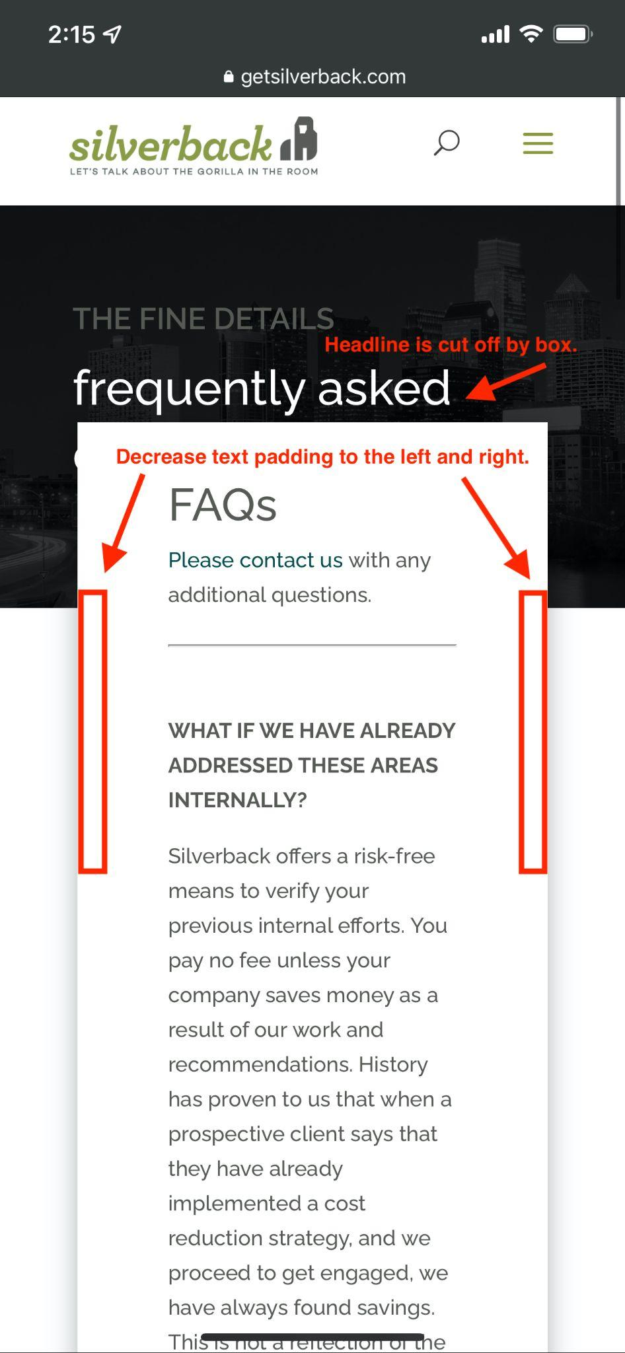

**Videos Page - Desktop:**

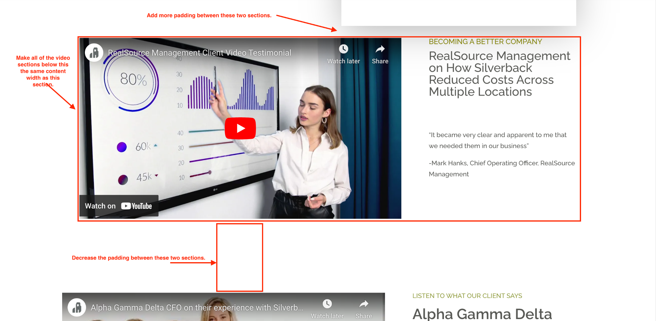

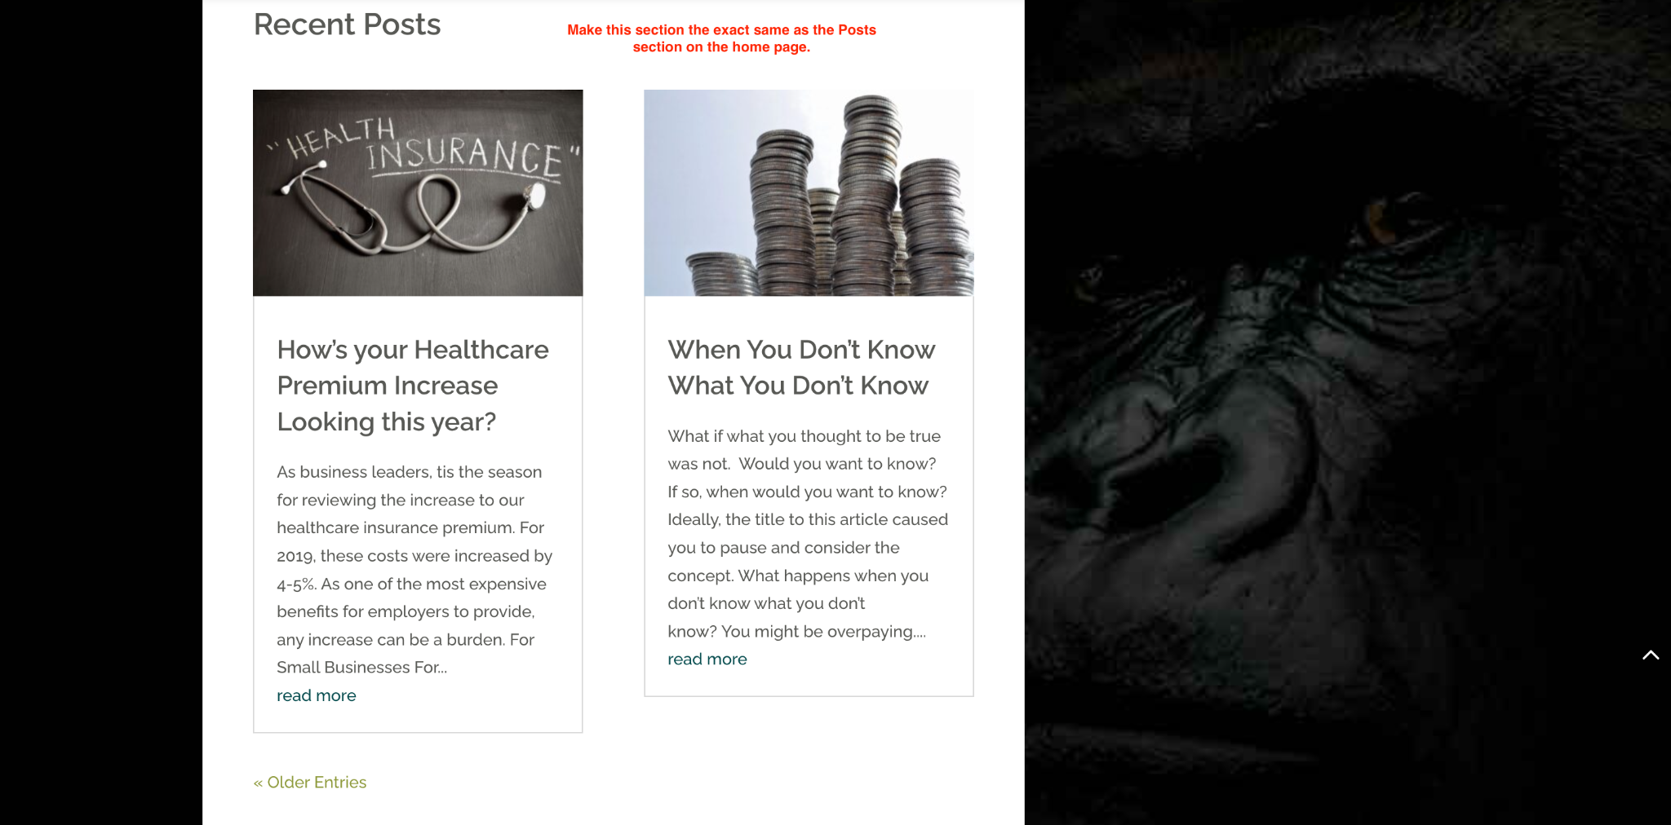

**Blog Archive Page:**

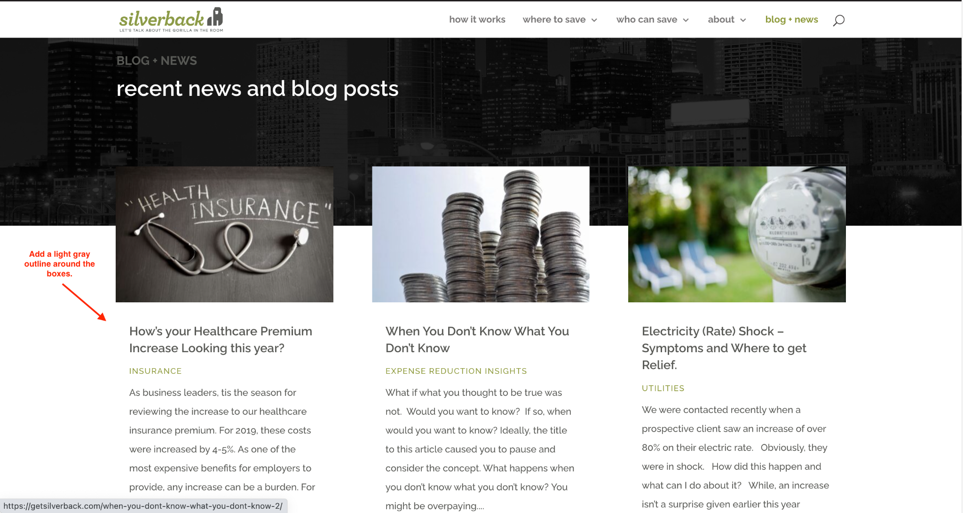

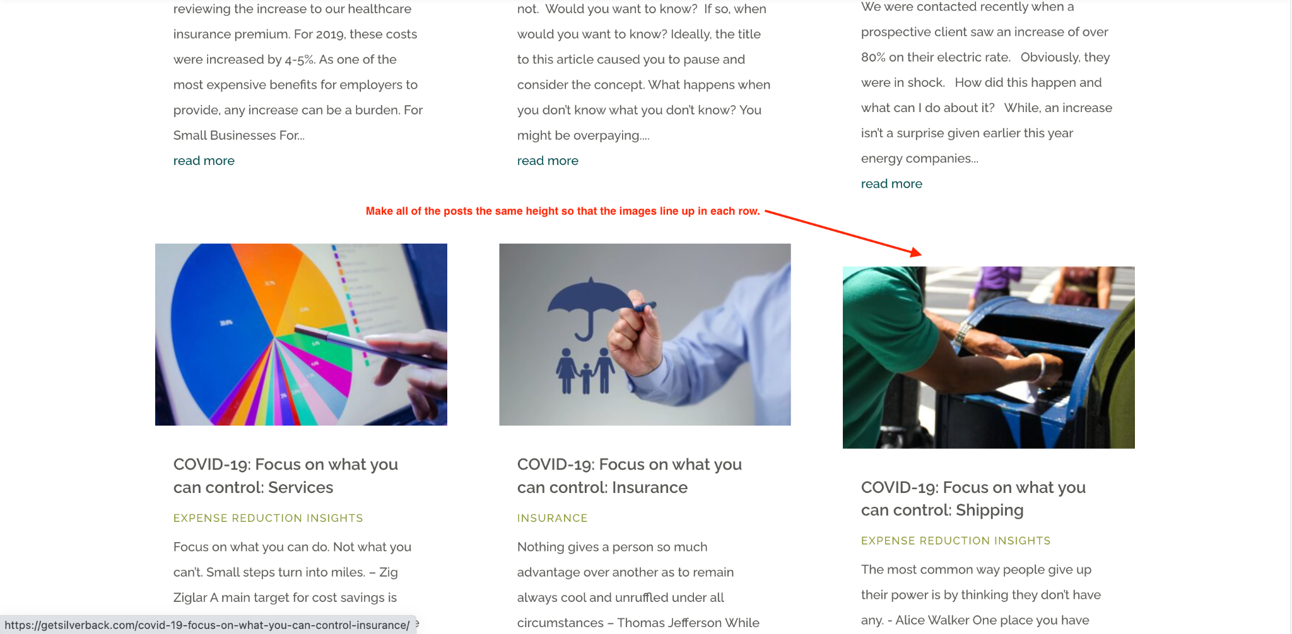

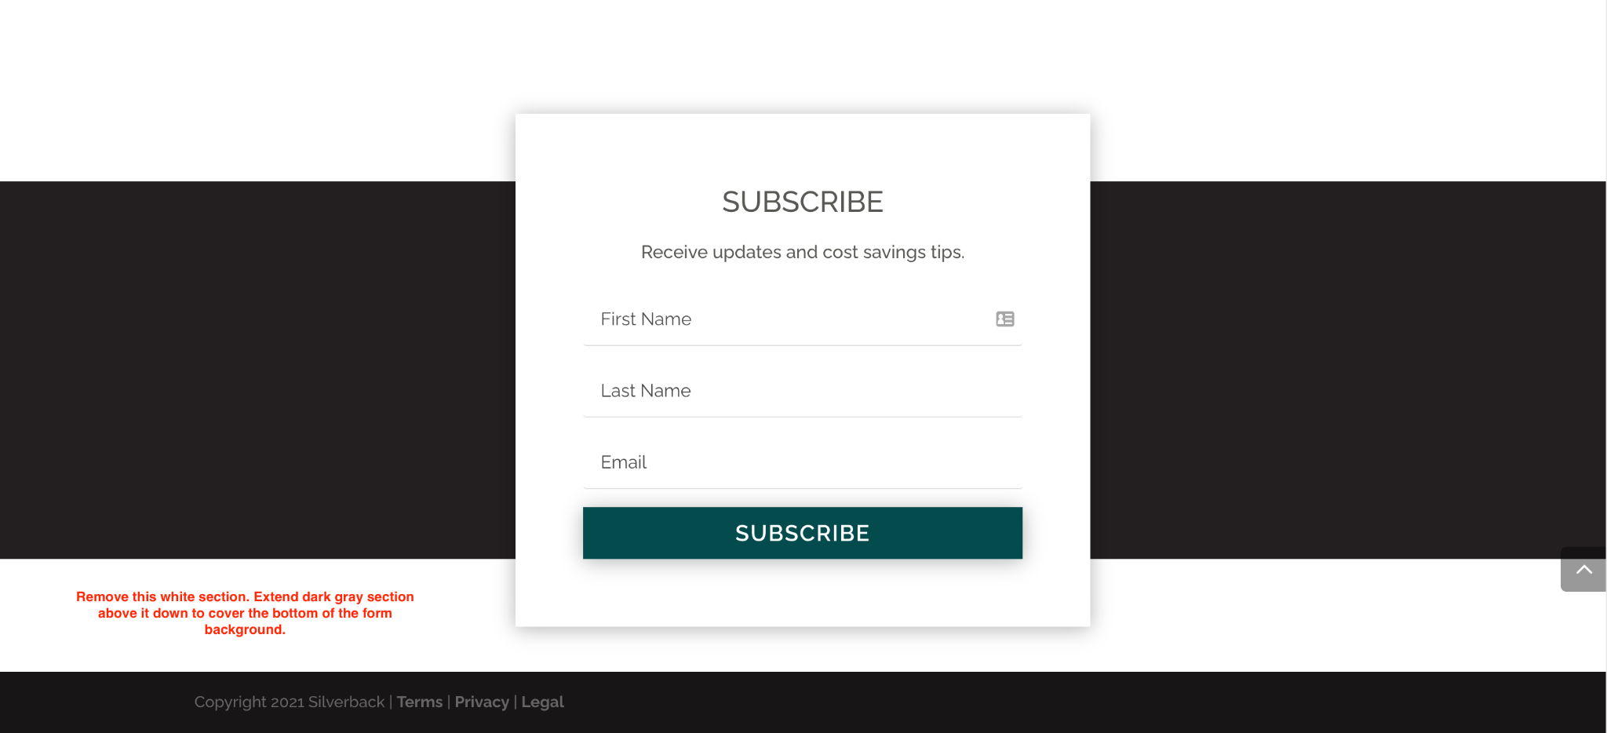

**Contact Page - Desktop:**

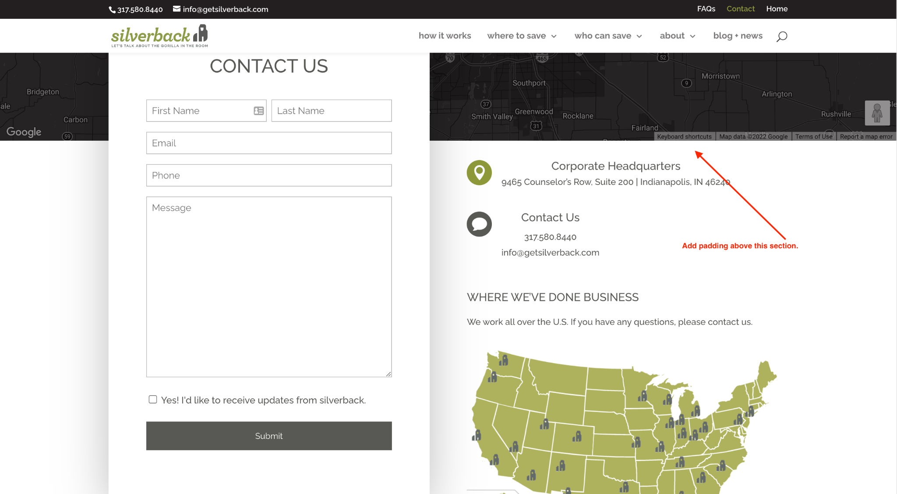

**Contact Page - Mobile:**

